What is the DAT?
It is a measure of an applicant’s general academic ability, their comprehension of scientific materials and perceptual ability.
The scores are used by dental schools to evaluate candidates for admission. Some schools vary in their emphasis on different sections of the test.
The test is multiple choice and fully computerized.
Tests are taken at a Prometric Testing Center.

Based on a 1-30 Point Scale
Average: National (17-18) ASDOH (19-20)
Competitive: 20+
Minimum: 17
Section by section, ASDOH considers 17 or over on all sections to be competitive.
If the DAT is retaken, ASDOH likes to see continued improvement on all sections.
If the DAT is retaken more than 3 times, then it makes the applicant look less competitive.

About the DAT...
Sign up at www.ADA.org/DAT
Register to receive your DENTPIN which will be your personal ID to sign up for the DAT (And future tests like the NBDE Boards Examinations once when you’re in Dental school)
DAT Guidebook www.ada.org/~/media/ADA/Education%20and%20Careers/Files/dat_Examinee_guide.ashx
Costs: $445
Rescheduling:
$100 1-5 business days before scheduled test date
$60 6-30 business days before scheduled test date
$25 31+ business days before scheduled test date
Can take up to 3 times (after 3rd time requires special request)
90 day wait in between tests
Scores valid for 3 years.

ASDA Membership
There are many benefits of being a ASDA member as a pre-dental student. Regarding DAT preparation, here are a few benefits:
A discount code is given for different programs
10% off - Crack the DAT
25% off - Chad’s Videos (Coursesaver)
25% off - Memorang (Practice questions, Exams, Games)
DAT Question of the Day - an email is sent every day containing practice question from the DAT along with an explanation of the answer.
A free copy of ASDA’s Getting into Dental School - book containing detailed information on every U.S. Dental school and statistics on GPA, DAT scores of the previous year.

Exam Breakdown
Total Time: 5 hours
Optional Tutorial (15 minutes)
CHECK IT OUT: www.prometric.com/ClientFiles/ada/DAT/
Survey of the Natural Sciences (90 minutes)
Biology (40 questions)
- Cell and Molecular Biology, Diversity of Life, Structure and Function of Systems, Developmental Biology, Genetics, Evolution, Ecology, Behavior
General Chemistry (30 questions)
- Stoichiometry and General Concepts, Gases, Liquids and Solids, Solutions, Acids and Bases, Chemical Equilibria, Thermodynamics and Thermochemistry, Chemical Kinetics, Oxidation-Reduction Reactions, Atomic and Molecular Structure, Periodic Properties, Nuclear Reactions, Laboratory
Organic Chemistry (30 questions)
- Mechanisms, Chemical and Physical Properties of Molecules, Stereochemistry (structure evaluation), Nomenclature, Individual Reactions of the Major Functional Groups and Combinations of Reactions to Synthesize Compounds, Acid-Base Chemistry, Aromatics and Bonding
Perceptual Ability Test (60 minutes)
Keyholes (15 questions)
Top-Front-End (15 questions)
Angle Ranking (15 questions)
Hole Punching (15 questions)
Cube Counting (15 questions)
Pattern Folding (15 questions)
Reading Comprehension (60 minutes)
3 passages (50 questions total)
- Passages on various scientific topics, not necessarily pertaining to dentistry.
Quantitative Reasoning Test (45 minutes)
On screen calculator (40 questions)
- Algebra, Data Analysis, Interpretation, Sufficiency, Quantitative Comparison, Probability and Statistics, Applied Mathematics (Word) Problems

Resources
There are many resources out there, but it’s most important to stick with a few and use it to the fullest. There really is no foolproof method to score well on the DAT other than diligence and patience. It’s what you make of the experience! Treat it like your job or significant other!

Practice Tests
It is important to treat each practice test as the real thing. Keep the time, practice endurance and pace from the beginning!
ADA Practice Test
www.ada.org/~/media/ADA/Education%20and%20Careers/Files/dat_test_sampleitems.ashx
- Free
- Generally used as a pre-assessment test before you start studying. Helps to gauge where you stand and what subjects to focus on.
DAT Bootcamp
www.datbootcamp.com
- $199 (but seems to be $137 as of now)
- 1 free test, 4 additional tests with 90 day license
- 5 additional PAT, Math section tests.
- Difficulty is representative of the actual test.
Crack the DAT
www.crackdat.com/purchase
- Different bundles available with different pricing
- Can purchase separate subject packages
- One time purchase, one device only
- Generally easier than the actual test.
- Best if used to get down the timing and build up endurance.
- The format/user interface is most representative of the actual test.
Top Score
www.scholarware_com.secure.myhosting.net/products-dat.htm
- $60 CD purchase
- 7 month license
- 3 tests
- Difficulty is representative of the actual test.
DAT Achiever
www.3tquest.com/index.php?module=products
- Different bundles available
- $70-$200 / 120-180 day license.
- 3-10 tests available
- Difficulty is harder than the actual test.

Institutions
Pros: Gives you a structure to follow after. Follow the institution's pace and study schedule.
Cons: Generally expensive. Only their materials are used.
Kaplan
- Sign up at: www.kaptest.com/dat
- Different packages available:
Packages Offered | Description | Estimated Price
Self-Paced | Pre-recorded lectures online | $1,299
In Person / Live Online | Instructor-led course:  1-2x a week for 6-8 weeks | $1,499
Private Tutoring | - | $2,999+

- Highlights:
  - All packages come with same resources (lesson books, online material, flashcards, practice tests, etc.)
  - Pros: a lot of available study material, 6 full-length practice tests, provides structure and deadlines
  - Cons: price, set schedule, not needed for everyone

Princeton Review
- Sign up at: www.princetonreview.com/medical/dat-test-prep
- Private Tutoring
- Princeton Review’s Resources used:
Self Study
Pros: Flexibility with how much you study and what resources you use. Create your own study guide and pace.
Cons: Hard to keep motivated. Easy to get distracted and maintain intensity.

Study Guide/Schedule Samples
Keep in mind that everyone studies and works at a different pace. Be sure to not compare yourself with what others are doing, but rather find the best study method/pace for you.
MinJae’s Study Guide (1.5 Months)
- Week 1-4 (Learn Material)
  - Monday - Friday (10AM-1PM, 2PM-7PM)
    - Biology everyday for a month (There’s really no end to how much you can know and be ready.)
    - Rotate 2 Subjects every 2 weeks (Organic Chemistry, General Chemistry, Reading)
    - PAT and Math as light studying
  - Saturday
    - Full, timed assessment and afterwards, REST!
  - Sunday
    - Review problems from Saturday and learn if necessary.
- Week 5-6 (Practice)
  - Take practice tests and review every three days for a total of 4 times.
    - Example: Monday-Test, Tuesday-Review, Wednesday-Continue Review/Rest, Thursday-Repeat
Aries’ Study Guide (1.5 Months)
- Week 1-4 (Learn Material)
  - 2 subjects a day, with emphasis on Biology and other weak areas
  - Flashcards
  - Full-length test once a week with review
  - Fridays: PAT, math to relax
  - Weekends: Light review, go outside
- Week 5-6 (Problem Sets)
  - Full-length test every other day with review
  - Do problem sets (DAT Destroyer, etc.)
  - Flashcards!
- Day Before Test
  - No studying!
Arik’s Study Guide (10 Weeks)
- Used Bootcamp’s study schedule/materials
  - Study Guide www.datbootcamp.com/Ari'sStudyGuide.pdf
  - Schedule s3.amazonaws.com/datbootcamp/Ari%27sStudySchedule.pdf
  - Biology Flashcards www.datbootcamp.com/feralis-biology-notes-anki-deck/
- Week 1-5 (Content Review)
  - Follow Bootcamp’s daily schedule
  - Chad is the MAN!
  - Start memorizing Destroyer Road Maps
  - Use DAT standard periodic table
  - Biology Flashcards - Anki
  - Practice PAT early and often
  - Self Control/Rescuetime App
    - www.selfcontrolapp.com - Use this app to block website so you don’t get distracted while studying
    - www.rescuetime.com - Use this app to check how much time you spend on each website you visit
- Week 5-10 (Practice Problems)
  - Use them to learn, review the content you need most help with
  - Turn your weakness into strengths by keeping a question bank of things you got wrong and review!
DAT Destroyer
http://www.orgoman.com/datdestroyer.html
It is very important to go through ALL the problems as some of the books have harder questions toward the end or cover the more important but uncommon topics.
- $150 Paper Book for purchase (No PDFs allowed)
- Use the Destroyer series as a learning tool and not an assessment!
- Practice questions on Organic Chemistry, General Chemistry, Biology, Quantitative Reasoning
  - Quantitative Reasoning problems are easier than the actual DAT and doesn’t cover the newer topics that were added recently.
  - For Biology, the format is not the same as the actual DAT. But it’s crucial to not just focus on the right answer for the question, but learn why the wrong answers are wrong. In other words, one question containing 5 answer choices results in learning and reviewing 5 topics.
  - For Organic Chemistry, highly recommend getting the Organic Chemistry Odyssey and starting with that first and save the Destroyer organic chemistry problems for additional review later.
  - For General Chemistry, use Chad’s Videos to supplement the Destroyer questions.
Math Destroyer
- $100 Paper Book for purchase (No PDFs allowed)
- Additional 18 tests of 40 questions each. (720 questions total)
- Difficulty is slightly harder than the actual DAT.
- Contains questions that were recently added into the actual DAT that isn’t in the Destroyer book.
- If you’re able to solve all the problems with a fair amount of ease, you won’t have much to worry about the actual test.
Organic Chemistry Odyssey
- $130 Paper Book for purchase (No PDFs allowed)
- Additional 900 problems that are very well structured and strategically divided into sections. (Alcohols, Acid and Bases, Stereochemistry, Aromatics, etc)
- Highly recommend if you haven’t touched organic chemistry for a while. Very well structured and divided by sections. (Alkanes, Alkenes, Aromatics, etc)
General Chemistry Destroyer
- $130 Paper Book for purchase (No PDFs allowed)
- Recently released and as a result can’t give a recommendation. But based on the content of Math Destroyer and Organic Chemistry Odyssey as supplemental practice problems, it should be very beneficial and worth your time.
Chad’s Videos
www.coursesaver.com/video/category/dat-videos
- $50 for 30 day license
- Used for General Chemistry and Organic Chemistry
- End of the video quizzes with answers
- Free biology videos - but not needed.
- Start off with watching these videos before diving into these two sections
Khan Academy Videos
www.khanacademy.org
- Free!
- Well put together videos teaching various subjects, especially Biology. Almost every possible biology topic is covered.
- Refer to these videos during DAT Destroyer Biology section.
Barron’s/Cliff’s AP Biology
- FREE PDF LINK (Cliff’s 3rd Edition): https://d3jc3ahdjad7x7.cloudfront.net/eYi7l6kHHrjBXFgOFMJn0hkd2hhDo6esBwXuv0a4mGhV3usT.pdf
- Under $15 from Amazon for a paper copy.
- Used to start off studying for the biology section and get a very general refresh of the subject.
- Not necessarily needed if you’re coming straight out of undergrad and biology courses.

Practice Test
Each question on the DAT should be solved in about less than a minute. If this is your first time, don’t stress too much. Everyone started off slow and everyone in the end got up to speed. It’s all about practice, practice, practice!
Take 10 minutes to solve these 11 questions (One question from each section of the DAT).

___________________________________________________________________________________________________

1 Biology
All of the following statements are part of modern cell theory EXCEPT one. Which one is the EXCEPTION?
- An organism’s activity is dependent on the activity of its independent cells.
- Metabolism and biochemistry occur within cells
- Hereditary information is stored in cells and is shared between cells during cell division.
- All cells contain a nucleus for the storage of genetic material
- All cells in organisms of similar species have similar chemical compositions.
___________________________________________________________________________________________________
2 General Chemistry
A sample of chromium oxide is 76.5% chromium by weight. What is the simplest formula of the oxide?
- CrO₃
- CrO₂
- CrO
- Cr₂O
- Cr₂O₃
___________________________________________________________________________________________________
3 Organic Chemistry
What is the major product of the Markovnikov addition of H-Br to the following molecule?
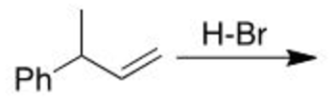
- 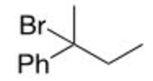
- 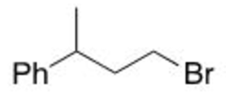
- 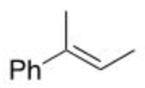
- 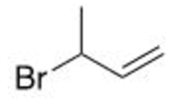
- 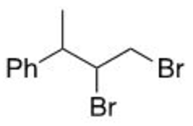
___________________________________________________________________________________________________

4 PAT - Keyhole
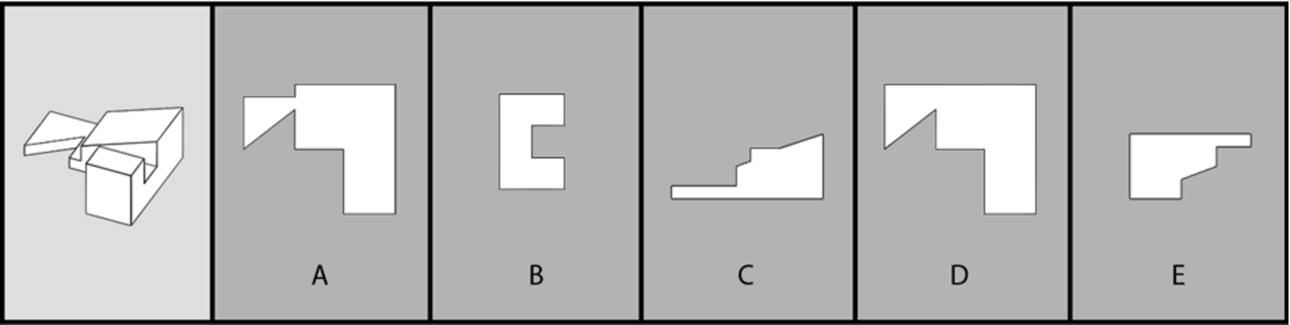
___________________________________________________________________________________________________
5 PAT - Top-Front-End
Choose the correct top view.
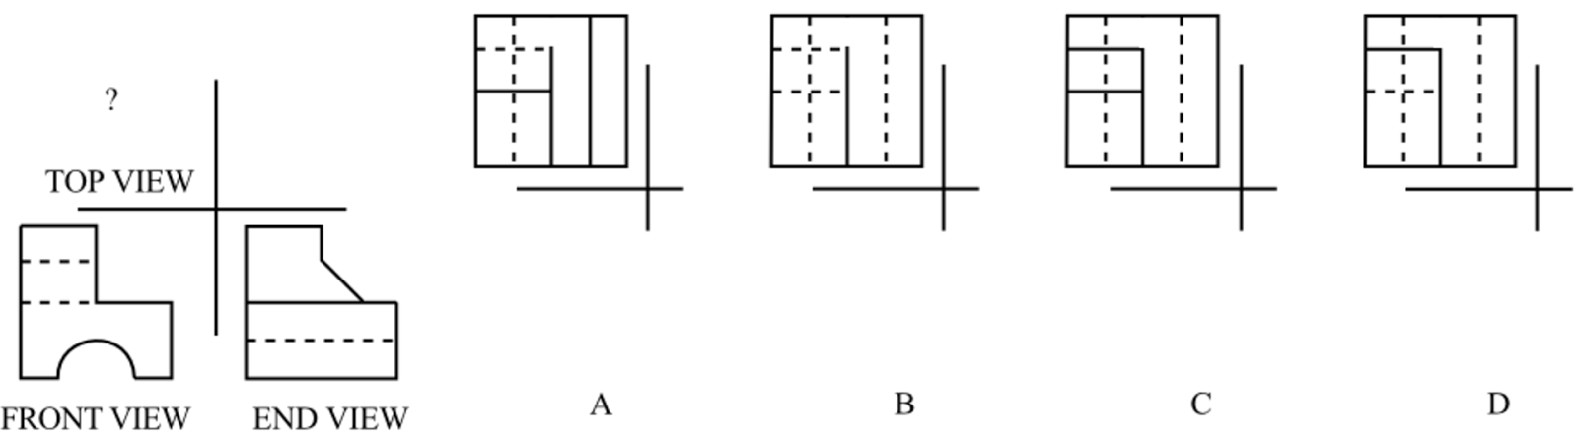
___________________________________________________________________________________________________
6 PAT - Angle Ranking
Rank the angles from least to greatest.
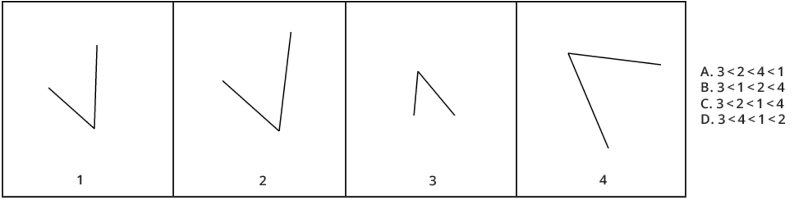
___________________________________________________________________________________________________

7 PAT - Hold Punch
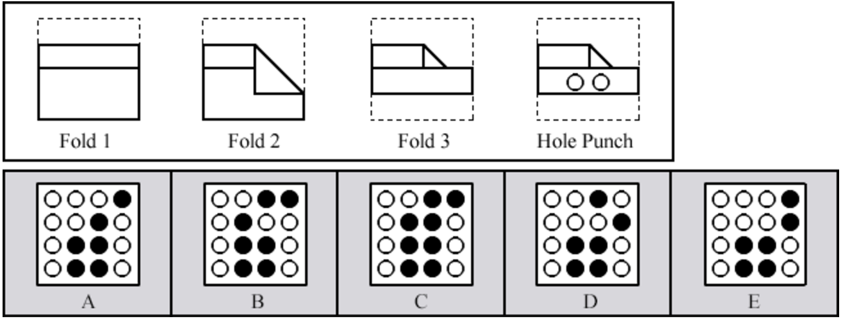
___________________________________________________________________________________________________
8 PAT - Cube Counting
In Figure D, how many cubes have three of their sides painted?
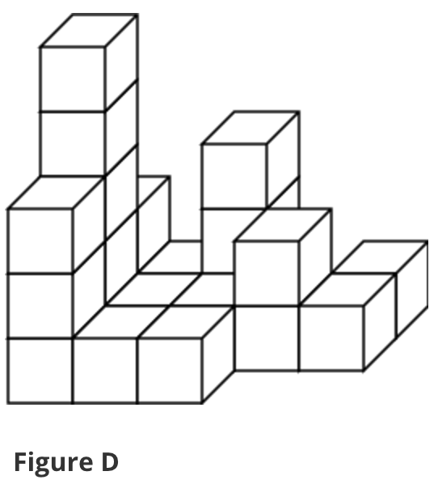
- 4 cubes
- 5 cubes
- 6 cubes
- 7 cubes
- 8 cubes
___________________________________________________________________________________________________
9 PAT - Pattern Folding
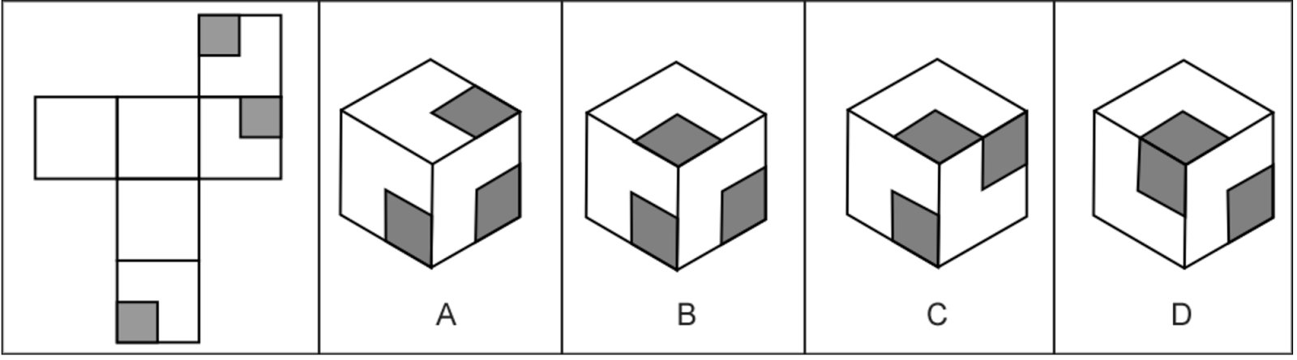
___________________________________________________________________________________________________
10 Reading Comprehension
Read the following passage and answer the question

By definition, aerosols are suspensions in air of solid or liquid particles, small enough that they remain airborne for prolonged periods because of their low settling velocity. The median diameters at which particles exhibit aerosol behavior also correspond to the sizes at which they are efficiently deposited in the lower respiratory tract when inhaled. Particles of >6µm diameter are trapped increasingly in the upper respiratory tract, while no substantial deposition in the lower respiratory tract occurs at larger sizes. Many authors adopt a size cutoff of <5µm for aerosols. This convenient convention is, however, somewhat arbitrary, because the long settling time and the efficient deposition in the lower respiratory tract are properties that do not appear abruptly at a specific diameter value. Certainly, particles in the micron or submicron range will behave as aerosols, and larger particles will settle rapidly, will not be deposited in the lower respiratory tract, and are referred to as large droplets.

What are aerosols?
- Small blasts of air
- A type of spray
- A dispensing system for liquids and gases
- Suspensions of solid or liquid particles
- Gas released into the air after being converted from a solid or liquid form
___________________________________________________________________________________________________
11 Quantitative Reasoning
Johnny has 15 toys with a total value of $125. If some of Johnny’s toys are worth $5 and the others are worth $10, how many toys does Johnny have that are worth $5?
- 5
- 7
- 8
- 10
- 13
___________________________________________________________________________________________________

